Final submission copy/paste: What is in bold should be libraries that are used throughout all questions and the code chunk that is given to manage the code before answering questions. These shouldn’t be repeated for individual questions

rm(list=ls())
# Read in used packages
library(readxl)
library(tidyverse)
library(ggplot2)
library(patchwork)

# Import the data into an object called frogs
frogs <- read_excel("CalaverasData.xls")

# Update code, given code
#Chunk #2
frogs <- rename(frogs,
day = Day,
frog_type = `rent/ind/pro`,
distance = `jump distance`,
jump_n = `jump #`,
distance_rel = `Relative to jump #1`,
distance_3 = `3-jump dist`,
distance_3_off = `measured 3-jump`,
duration = `jump duration`,
angle_00 = unknown1,
angle_01 = angle,
angle_10 = unknown2,
velocity_00 = unknown3,
velocity_01 = Vel,
velocity_10 = unknown4
) %>%
mutate(
row = seq_len(nrow(.))
) %>%
select(row, everything())

#Chunk #3
frogs <- frogs %>%
mutate(jump_n = as.integer(jump_n))

#Chunk #4
## frog_type
frogs <- frogs %>%
mutate(
frog_type2 = case_when(
frog_type == 1 ~ "rental",
frog_type == 2 ~ "individual",
frog_type == 3 ~ "pro",
frog_type < 0 ~ "unknown"
)
)

#1:
# In chunk #1, we use the library function to call in the tidyverse package,
# which is a set of packages (including dplyr, stringr, ggplot2, and a few
# others) that have similar data representations and designs. Then, I added
# another library function to call in the readxl package, which allows us to
# read in Excel files through code.

# In chunk #2, to use the starter code, we attach the read_excel function,
# which allows us to read in our specific frogs data set through our file
# directory, to an object called “frogs” by using a left arrow, “<-.” The
# read_excel function helps us avoid manually importing the Excel file each
# time we load RStudio and want to work with a specific data set. It also tells
# us that we have 3272 observations of 14 variables in our environment.
# In the next part of chunk #2, we call the object frogs again and use the
# rename function, which allows us to rename old variables into new ones. In
# this case, we call the “frogs” dataset, and we uncapitalize, generalize,
# shorten, and properly label variable names. A couple of examples of renamed
# variables include the old name of “unknown3” to “velocity_00” and
# “rent/ind/pro” to “frog_type.” After the rename function is closed off, we
# use a pipe operator “%>%” to call another function, the mutate function, but
# for the same dataset and in consideration of all of the variables we just
# renamed. The mutate function creates a new variable and column, called “row”
# that uses the function seq_len, which generates a sequence with a specified
# length inside of another function, nrow, which returns the number of rows
# present in the data frame. The overall purpose of this code is to create a
# new variable called row that essentially counts the number of rows in a
# specific order (e.g., 1 to 10 in order).
# In the final part of chunk #2, we use the select function, which specifically
# calls the new variable, row, and uses the everything function to select all
# of the variables to be shown in the first column, matching the row numbers.

# In chunk #3, we make another object, still called frogs, that calls for the
# frogs dataset, then uses a pipe operator, which allows the functions used
# below it to assume that the frogs dataset is being used. Below the pipe
# operator, we have another mutate function that is creating a second new
# variable named “jump_n” that uses the old “jump_n” variable as an integer
# with the as.integer function.
# In chunk #4, we make another frogs object that calls for the frogs dataset,
# then uses a pipe operator where another mutate function is creating a third
# new variable named “frog_type2” that uses the case_when function, which
# allows us to vectorize multiple if-else statements sequentially. The new
# variable, frog_type2, uses the original variable, frog_type, and assigns
# names to the numbers that represent each type of frog that is known. Any
# frogs represented by “-1” and were of an unknown type were labeled as
# “unknown” through this function. For the frog types 1, 2, and 3, they were
# labeled as rental, individual, and pro, respectively.

#2a: What is the average distance jumped in the study?
mean(frogs$distance)
# The average jump is 123.7054cm.

#2b: What is the average distance jumped for rental frogs (frog_type of 1)?
# Of professional frogs (frog_type of 3)? Use base R

# Rental frogs:
mean(frogs$distance[frogs$frog_type == 1])

# Professional frogs:
mean(frogs$distance[frogs$frog_type == 3])

# The average distance jumped for rental frogs is 79.75309cm, and the
# average distance jumped for professional frogs is 135.8276cm.

#2c: What is the furthest distance jumped in the study?
max(frogs$distance)
# The furthest distance jumped in the study is 219.78cm.

#2d: What is the average distance jumped for rental frogs? Of professional
# frogs? For each question, write a single line of code using dplyr and
# tidyverse tools.

# Rental frogs:
frogs |>
filter(frog_type == 1) |>
summarise(mean_rental_jump = mean(distance))
# The average distance jumped for rental is 79.8cm.

# Professional frogs:
frogs |>
filter(frog_type == 3) |>
summarise(mean_rental_jump = mean(distance))
# The average distance jumped for professional is 136cm.

#2e: How many rental frogs are in the study? How many professional frogs
# are in the study? Write a single line of code that will answer both
# questions simultaneously.
frogs |>
count(frog_type)
# The number of rental frogs is 590 and the number of professional frogs
# is 2512.

#3: Omit '0' distance values and change cm to meters
frogs_graphs <- frogs |>
filter(distance != 0)

frogs_graphs <- frogs_graphs |>
mutate(distance_m = distance/100)

#3a
graphA <- ggplot(frogs_graphs, aes(x = distance_m)) +
geom_histogram(fill = "darkseagreen", color = "black") +
labs(x = " ",
y = " ") +
theme_classic() +
geom_segment(aes(x = 1.3,
y = 275,
xend = 1.30,
yend = 140),
arrow = arrow(length = unit(0.5, "cm")))

graphA

#3b
# subset so only rental
frogs_graphB <- frogs_graphs |>
filter(frog_type == 1)

graphB <- ggplot(frogs_graphB, aes(x = distance_m)) +
geom_histogram(fill = "grey", color = "black") +
labs(x = " ",
y = "Number of jumps") +
theme_classic() +
geom_segment(aes(x = 1.30,
y = 55,
xend = 1.30,
yend = 21),
arrow = arrow(length = unit(0.5, "cm")))

graphB

#3c
# subset so only professional
frogs_graphC <- frogs_graphs |>
filter(frog_type == 3)

graphC <- ggplot(frogs_graphC, aes(x = distance_m)) +
geom_histogram(fill = "darkgreen", color = "black") +
labs(x = "Jump distance (m)",
x = " ",
y = " ") +
theme_classic() +
geom_segment(aes(x = 1.30,
y = 275,
xend = 1.30,
yend = 118),
arrow = arrow(length = unit(0.5, "cm")))

graphC

# Combine using patchwork
graphA/graphB/graphC

#4:
#PART A
rent_frogs <- filter(frogs, frog_type2=="rental")
rent_frogs
pro_frogs <- filter(frogs, frog_type2=="pro")
pro_frogs

#PART B
set.seed(3470)

myrentsim <- replicate(5000, max(sample(rent_frogs$distance, 50, replace=FALSE)))
myrentsim

mean(myrentsim >= 160.000)

#PART C
myprosim <- replicate(5000, max(sample(pro_frogs$distance, 50, replace=FALSE)))
myprosim

mean(myprosim >= 160.000)

#5: Shiny App

rm(list=ls())

library(shiny)
library(tidyverse)
library(readxl)
# Import the data into an object called frogs
frogs <- read_excel("CalaverasData.xls")

frogs <- rename(frogs,
day = Day,
frog_type = `rent/ind/pro`,
distance = `jump distance`,
jump_n = `jump #`,
distance_rel = `Relative to jump #1`,
distance_3 = `3-jump dist`,
distance_3_off = `measured 3-jump`,
duration = `jump duration`,
angle_00 = unknown1,
angle_01 = angle,
angle_10 = unknown2,
velocity_00 = unknown3,
velocity_01 = Vel,
velocity_10 = unknown4
) %>%
mutate(
row = seq_len(nrow(.))
) %>%
select(row, everything())

#Chunk #3
frogs <- frogs %>%
mutate(jump_n = as.integer(jump_n))

#Chunk #4
## frog_type
frogs <- frogs %>%
mutate(
frog_type2 = case_when(
frog_type == 1 ~ "rental",
frog_type == 2 ~ "individual",
frog_type == 3 ~ "pro",
frog_type < 0 ~ "unknown"
)
)

rent_frogs <- frogs |>
filter(frog_type2 == "rental") |>
mutate(distance_m = distance/100)

# Define UI for application that draws a histogram
ui <- fluidPage(

# Application title
titlePanel("Analyzing How Different Sample Sizes of Frogs Affect Jump Distance Probabilities"),

# Sidebar with a slider input for number of bins
sidebarLayout(
sidebarPanel(
sliderInput("n",
"Sample Size of:",
min = 1,
max = 100,
value = 50),
numericInput("distance_m",
"Distance jumped (m):",
min = 0.0001,
max = 3,
value = 1.6)

),

# Show a plot of the generated distribution
mainPanel(textOutput("myText"),
plotOutput("distPlot")
)
)
)

# Define server logic required to draw a histogram
server <- function(input, output) {

output$myText <- renderText({
set.seed(3470)
n <- input$n
distance_m <- input$distance_m
myrentsim <- replicate(5000, max(sample(rent_frogs$distance_m, n, replace=FALSE)))
prob <- mean(myrentsim >= distance_m)
paste(" 1) The sample size of frogs jumping is", n,
"2) the distance selected is", distance_m, "m",
"3) and the probability of frogs hitting/going over that distance is ", prob)})

output$distPlot <- renderPlot({
set.seed(3470)
n <- input$n
distance_m <- input$distance_m
myrentsim <- replicate(5000, max(sample(rent_frogs$distance_m, n, replace=FALSE)))
prob <- mean(myrentsim >= distance_m)

mytitle <- paste("Histogram Analyzing Sample Size of Frogs and Probability of Making Jumps")

ggplot(data.frame(myrentsim), aes(x = myrentsim)) + geom_histogram() +
labs(title=mytitle,
x = "Jump distance (m)")

})
}

# Run the application
shinyApp(ui = ui, server = server)

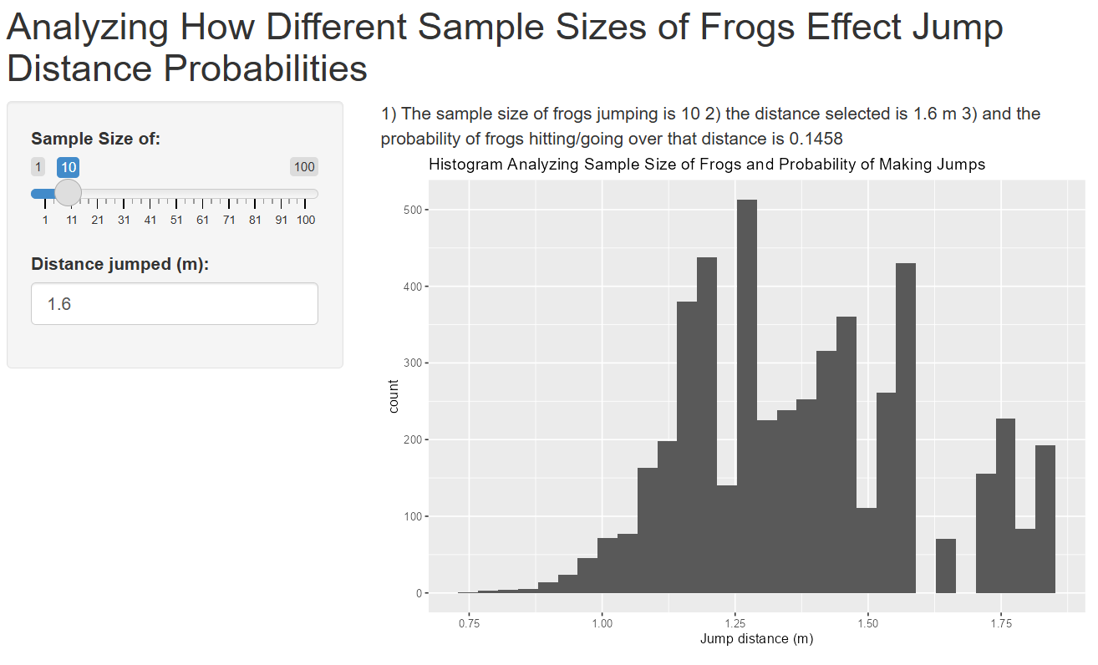
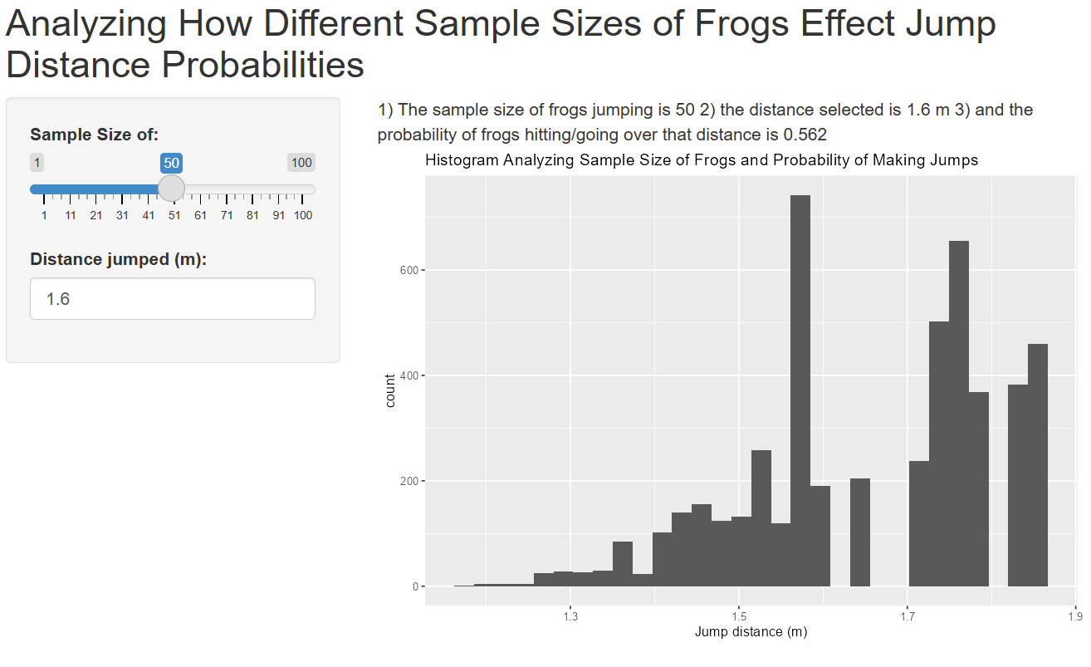
TO BE COMPLETED INDIVDUALLY: Each student should complete a reflection (at least 5 sentences for
each reflection question) by answering the following questions:
a. What was your biggest contribution to the project?
For the code, my biggest contribution was subsetting the data for step 4. I also was responsible for analyzing the starter code and writing our paragraphs for what each line did. I mostly used R’s descriptions for anything I was less sure on how to describe or explain. Kelly and I communicated and organized our schedules to meet up and checked in with each other over the phone when it was harder to meet in person. The project was very smooth for us overall, because we both have previous experience with R and working together for group projects.
b. What was the biggest challenge in this project?
I honestly don’t believe this project was very hard (outside of the shiny app code). However, Kelly is much more confident with the shiny app so we walked through that together (even though she was doing the most work for that portion of the project). Even on our most recent exam, I still struggle with shiny apps, even if I find the result interesting. I’m hoping it’s something I’ll understand as we keep using it in class, but I honestly might try to review it over break just so I feel more confident with it for future work.
c. What was the most interesting thing you learned while doing this project?
I love animals, so I thought this dataset was really fun to work with and make assumptions about. When I was analyzing the starter code, I learned more about the multiple purposes we can get from different functions. For example, when we use the tidyverse package and load it in with the library function, I did not realize that it was multiple packages included into one (including dplyr, which I’ve used before in previous classes). This is my first class using tidyverse over just dplyr, so it was interesting to see how the code can differ depending on the packages being used.

1- Analyze given code (starter code?) and describe in 3 paragraphs what each line of code does. If you didn’t know what specific lines of code did, explain how you solved it. Minimum of 3 strong paragraphs(so 15-21 sentences), C
4- Creating subsets of data and simulating code, C

Next weekend meeting at library draft due and double check each other, individual script files

Deadline is Wednesday the 11th

1. Run the code and provide a detailed narrative of what each chunk of code in the starter code accomplishes.
Indicate you how determined what any portion of code did that you were unfamiliar with. This should be at least
three solid paragraphs. The emphasis should be on the clarity of communication and clear demonstration of
your understanding of the code.

Note 1: The researchers published their paper using meters, but the raw data they made available (which you have
access to) appears to have recorded in centimeters. Note that 100 cm = 1 m.
Note 2: The researchers appeared to generate graphs that omitted any jump distances of 0 cm (or 0 m). Omit those
jumps in your graphs in #3.

In chunk #1, we use the library function to call in the tidyverse package, which is a set of packages (including dplyr, stringr, ggplot2, and a few others) that have similar data representations and designs. Then, I added another library function to call in the readxl package, which allows us to read in Excel files through code.

In chunk #2, to use the starter code, we attach the read_excel function, which allows us to read in our specific frogs data set through our file directory, to an object called “frogs” by using a left arrow, “<-.” The read_excel function helps us avoid manually importing the Excel file each time we load RStudio and want to work with a specific data set. It also tells us that we have 3272 observations of 14 variables in our environment.
In the next part of chunk #2, we call the object frogs again and use the rename function, which allows us to rename old variables into new ones. In this case, we call the “frogs” dataset, and we uncapitalize, generalize, shorten, and properly label variable names. A couple of examples of renamed variables include the old name of “unknown3” to “velocity_00” and “rent/ind/pro” to “frog_type.” After the rename function is closed off, we use a pipe operator “%>%” to call another function, the mutate function, but for the same dataset and in consideration of all of the variables we just renamed. The mutate function creates a new variable and column, called “row” that uses the function seq_len, which generates a sequence with a specified length inside of another function, nrow, which returns the number of rows present in the data frame. The overall purpose of this code is to create a new variable called row that essentially counts the number of rows in a specific order (e.g., 1 to 10 in order).
In the final part of chunk #2, we use the select function, which specifically calls the new variable, row, and uses the everything function to select all of the variables to be shown in the first column, matching the row numbers.

In chunk #3, we make another object, still called frogs, that calls for the frogs dataset, then uses a pipe operator, which allows the functions used below it to assume that the frogs dataset is being used. Below the pipe operator, we have another mutate function that is creating a second new variable named “jump_n” that uses the old “jump_n” variable as an integer with the as.integer function.

In chunk #4, we make another frogs object that calls for the frogs dataset, then uses a pipe operator where another mutate function is creating a third new variable named “frog_type2” that uses the case_when function, which allows us to vectorize multiple if-else statements sequentially. The new variable, frog_type2, uses the original variable, frog_type, and assigns names to the numbers that represent each type of frog that is known. Any frogs represented by “-1” and were of an unknown type were labeled as “unknown” through this function. For the frog types 1, 2, and 3, they were labeled as rental, individual, and pro, respectively.
Questions on #3 and #5 (graphs and shiny app)

- Show graphs, ask about arrows and what the last recorded maximum means
- Show shiny code and ask what’s going wrong with the histogram and what to do

